 | 12.1.70 Editors - Geometry Nodes Editor - Header - Add Menu - Geometry Nodegroups - Grease Pencil - Read
Table of content
Detailed table of content 1
Add menu - Geometry nodes - Grease Pencil - Read 1
Layer Size 2
Material Fill Info 2
Stroke Info 2

Detailed table of content
Detailed table of content
Detailed table of content 1
Add menu - Geometry nodes - Grease Pencil - Read 1
Layer Size 2
Material Fill Info 2
Stroke Info 2

Add menu - Geometry nodes - Grease Pencil - Read

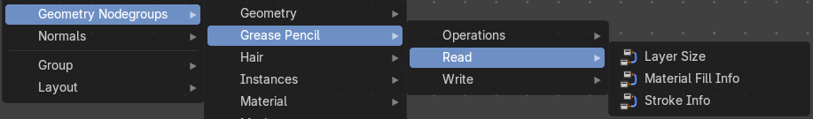
The nodes in this submenu are node groups. They use the regular single nodes under the hood.
It is virtually impossible to document these nodes in detail. So we will just list them.
When you double click the header, then you will enter the first level of the group. When you then press tab, or click again at the header, then you will reach the single nodes.




To leave the group you can use the breadcrumb up left in the header. These breadcrumbs are clickable. Or the Parent Node Tree button up right in the header.

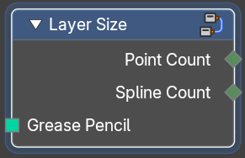
Layer Size
Retreive the point count and spline count of a grease pencil layer.

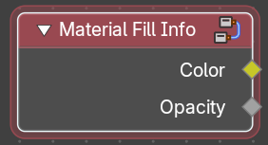
Material Fill Info
Retreive the color and opacity of a grease pencil layer.

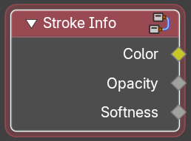
Stroke Info
Retreive the color, opacity and softness of a grease pencil stroke.

